2026/4/6 Start developing the project.
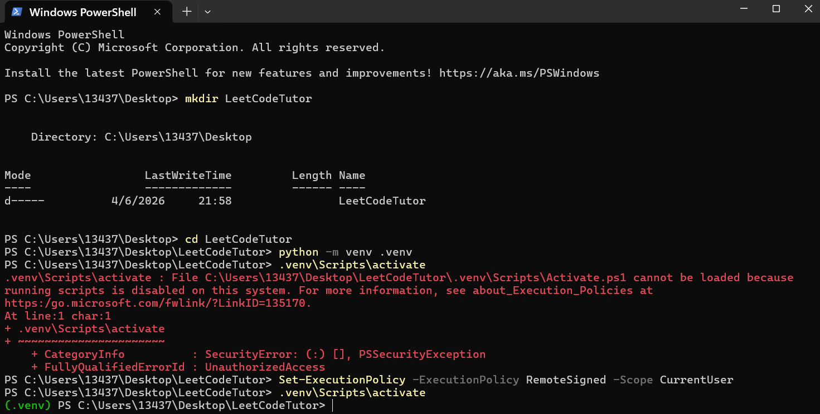

Testing file Back up
import os
from dotenv import load_dotenv
from langchain_google_genai import ChatGoogleGenerativeAI

def test_setup():
# 1. Load the secrets from your .env file
load_dotenv()

# 2. Verify the Gemini key actually loaded
gemini_key = os.getenv("GOOGLE_API_KEY")
if not gemini_key:
print("Error: GOOGLE_API_KEY not found! Check your .env file.")
return

print("Environment variables loaded successfully!")

# 3. Initialize the LangChain LLM
try:
print("Pinging Google Gemini...")
llm = ChatGoogleGenerativeAI(model="gemini-2.5-flash", temperature=0.2)

# 4. Send a simple test message
response = llm.invoke("You are a LeetCode Tutor. Reply with exactly: 'Tutor online and ready.'")

print("\n--- Response ---")
print(f"Gemini: {response.content}")
print("----------------\n")
print("Success! Your AI engine is connected.")

except Exception as e:
print(f"\nFailed to connect to Gemini. Error details:\n{e}")

if __name__ == "__main__":
test_setup()

backup 2
import os
import requests
from dotenv import load_dotenv

# Load environment variables from .env
load_dotenv()

LEETCODE_SESSION = os.getenv("LEETCODE_SESSION")
CSRF_TOKEN = os.getenv("LEETCODE_CSRF")
USERNAME = os.getenv("LEETCODE_USERNAME")

GRAPHQL_URL = "https://leetcode.com/graphql"

def get_latest_submission():
headers = {
"Content-Type": "application/json",
"Cookie": f"LEETCODE_SESSION={LEETCODE_SESSION}; csrftoken={CSRF_TOKEN}",
"x-csrftoken": CSRF_TOKEN,
"Referer": f"https://leetcode.com/{USERNAME}/",
"User-Agent": "Mozilla/5.0 (Windows NT 10.0; Win64; x64) AppleWebKit/537.36 (KHTML, like Gecko) Chrome/120.0.0.0 Safari/537.36"
}

# The GraphQL payload to get your latest submission list
payload = {
"operationName": "recentAcSubmissions",
"variables": {
"username": USERNAME,
"limit": 1
},
"query": """
query recentAcSubmissions($username: String!, $limit: Int!) {
recentSubmissionList(username: $username, limit: $limit) {
id
title
statusDisplay
lang
}
}
"""
}

try:
print(f"Fetching latest submission for {USERNAME}...")
response = requests.post(GRAPHQL_URL, headers=headers, json=payload)
response.raise_for_status()

data = response.json()
submissions = data.get("data", {}).get("recentSubmissionList", [])

if not submissions:
print("No recent submissions found. Go submit a problem on LeetCode first!")
return None

latest = submissions[0]
print("\n --- Latest LeetCode Submission --- ")
print(f"Problem: {latest['title']}")
print(f"Status: {latest['statusDisplay']}")
print(f"Lang: {latest['lang']}")
print(f"Sub ID: {latest['id']}")
print("--------------------------------------\n")

return latest

except Exception as e:
print(f"\nFailed to fetch from LeetCode. Error details:\n{e}")
return None

if __name__ == "__main__":
get_latest_submission()
Here is a complete debrief of what you just accomplished. This is exactly the kind of summary you can use to write a killer README for your GitHub repository or discuss in a technical interview for an internship.
🎯 Your Goal
You set out to build the "LeetCode Tutor Agent"—a custom AI engineering tool that automatically monitors your LeetCode profile, detects when you fail a problem, analyzes your broken code and the failed test case, and provides Socratic, guiding hints without spoiling the final answer. You also wanted it to automatically generate a permanent Markdown study guide of your mistakes.
🚧 Problems You Met & 🛠️ How You Solved Them
- The Data Access Problem: LeetCode has no official public API to pull submission data.
  - Solution: You reverse-engineered the undocumented GraphQL API by inspecting browser network payloads and extracted your secure LEETCODE_SESSION and csrftoken cookies to bypass the frontend and authenticate your Python script directly.
- The Environment Security Block: Windows PowerShell threw a PSSecurityException when trying to activate your virtual environment.
  - Solution: You modified the Windows Execution Policy (Set-ExecutionPolicy RemoteSigned) to safely allow local scripts to run on your machine.
- The Dependency & Pathing Mismatch: You encountered a ModuleNotFoundError for dotenv and issues with Cursor finding the .env file.
  - Solution: You successfully mapped Cursor's Python Interpreter to your specific .venv bubble, ensuring the script executed in the correct isolated environment, and verified exact file naming conventions to prevent hidden Windows extensions.
- The AI Quota & Routing Errors: You hit a 404 NOT_FOUND and a 429 RESOURCE_EXHAUSTED error when trying to connect to the Gemini API due to versioning and free-tier paywalls.
  - Solution: You navigated Google's API architecture and downgraded from the restricted 3.1-pro preview model to the stable, high-speed, free-tier-friendly gemini-1.5-flash model.
💻 Technology Applied
- Python: The core scripting language connecting the components.
- LangChain: Used as the orchestration framework to build the PromptTemplate and pipe your data seamlessly into the LLM.
- Google Gemini API (gemini-1.5-flash): The reasoning engine used to analyze the code logic and edge cases.
- GraphQL & requests: Used to structure payloads and execute HTTP POST requests to query LeetCode's database.
- python-dotenv & .venv: Applied for strict environment isolation and secure secret management.
- File I/O (datetime): Used to autonomously generate and append timestamped logs to a local Markdown file.
🧠 Thinking & Architecture Applied
- Security-First Architecture: You learned the critical difference between an API (the menu) and an API Key (the credit card), ensuring your credentials were locked in a .env file and protected by .gitignore so they never leak online.
- Prompt Engineering (The Socratic Method): You strictly constrained the AI's behavior via system prompts, forcing it to act as a teacher that guides you to the "off-by-one" sliding window error, rather than an autocomplete tool that just rewrites the code.
- Modular Design: You structured the codebase logically: breaking it into Authentication, Data Fetching (The Eyes), AI Analysis (The Brain), and Data Logging (The Memory).
🚀 What Can Be Improved (Next Steps)
To take this project from a great script to a masterpiece, here are a few ways you could level it up:
- The Practice Problem Generator: We discussed this at the start! You could add a second LangChain prompt that automatically generates a mini-problem (similar to a LeetCode Easy) that isolates the exact logical concept you just failed, appending it to your study guide.
- Continuous Polling (Background Daemon): Right now, you have to run python main.py manually. You could wrap the main block in a while True: loop with a time.sleep(15) so it runs continuously in the background while you code, instantly pinging you the moment you fail a submission on the website.
- GUI or Notifications: Instead of just printing to the terminal, you could use a library like plyer to trigger a native Windows desktop notification on your HP Omen when the AI finishes analyzing your code.
- Database Integration: Upgrading the Markdown logger to save your failures into a lightweight SQLite database, allowing you to easily query your most common failure types (e.g., "Show me all my sliding window errors").

